1.

(1)true

(2)false,

an is-a relationship represent inheritance,by contrast,a has-a relationship represent composition

(3)true

(4)false,

the members are hidden in derived class,and a base class’s private members are accessible only within its body and to the friends of that base class.

(5)true

2.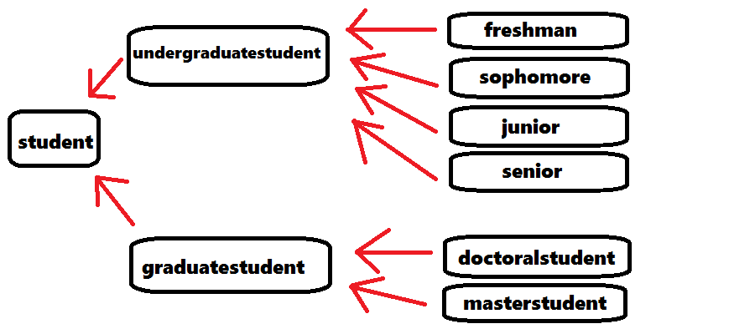

the relationships that exist between the classes are is-a relationships